SW Engineering CSC648/848 Summer 2016

Application: Gatorslist

Milestone 2

July 12th, 2016

Rev 1.0

Team 1

Khalid Alrashed (alrashed@mail.sfsu.edu),

Eric Chen, Robert Chung,

Tai Nguyen, Guoyi Ruan.

Table of Contents

1. Use Cases 3

2. Data Definition 4

3. Functional Requirements 6

4. Non-Functional Requirements 8

5. UI Mockups and Storyboard 10

6. High Level Architecture, Database Organization 15

7. High Level UML Diagrams 19

8. High level APIs 21

9. Key Risks 24

10. Team Organization 25

1. Use Cases

**User-Friendly Home Page**

John is an SFSU student currently in his sophomore year. John had a bad experience buying textbooks directly from the campus store because of how expensive they are, and so this time he decides to go to Gatorslist this time. On Gatorslist he is presented with a simple layout of textbook images and their titles underneath, sorted by the most recently added. He can then easily navigate through the list and look search for the textbooks he needs at an affordable and competitive price.

**Search (Unregistered User)**

Consuela wants to head-start her semester at SFSU and organize her life a little better. Instead of waiting a week or two to get the textbooks required for her classes, she decides to start shopping a little earlier. Only problem is the professors haven’t posted the syllabus yet and she doesn’t know what books she might need, so she goes to Gatorslist. On the home page, she finds a big search bar with a drop down list of subjects (categories) of books like Philosophy, Computer Science, and so on with the major abbreviation appended in parenthesis. She’s looking for a History book, so she clicks on History from the list and clicks search. That takes her to a Search Results page with a listings of history books only. She can modify the search and go further by searching by price (high or low) and date posted (new or old). Consuela rights down the class’ name on the search box, clicks submit and is taken to the listing with the exact book she was looking for.

**Register and Sell Textbooks**

Rebecca is graduating from SFSU this semester. Over the years at SFSU she has bought many textbooks for her classes, and has a massive collection as a result. But now she’s planning to move out, and doesn’t have the space to take her books with her, so she decides to go to Gatorslist and sell them. On the website’s homepage she sees a “Sell Your Book” button on the navigation bar and clicks on it. This prompts her to register if not logged in, and after that’s done, she’s taken to the “Sell Your Book” page where she can post her textbooks with their images and specify the price, subject (category), condition, along with a description of the book. After she submits the post, her page is updated with the post listings.

**Buy Textbooks**

Marc is on the 2nd month of the semester at SFSU, and realizes that he should’ve bought the book for his major class. The book store has just sold out, and will require a special order that will take a long time. Marc can’t wait that long as he needs the book right now. This is where he finds Gatorslist. He searches for the books he needs, clicks on the book he wanted from the search results. That takes him to the product details page where he is presented with a large picture of the book with the title and price above it, and condition of the product and a description on the right. He registers for a new account if not yet registered, enters his payment method of choice, and sets up the meeting with the seller within SFSU campus. He can then confirm the transaction after he has picked up the book. Marc is pleased with the time it took to get the book he needed.

**Administrator**

Gatorslist is maintained by an admin user that looks over and manages user accounts along with product listings. If a user submits a book to be sold, it will have to be verified by an admin first before the post become visible to everyone. This insures that users follow post submission guidelines and protects the website’s users from unwanted content.

1. Data Definition

2.1 Term Description

|  |  |  |
| --- | --- | --- |
| **Term** | | **Description** |
| Unverified User | Guest | Browse the website.  Search products.  View products. |
| Verified User | Buyer | Have all rights of unverified users.  Create, login and logout account.  Order products on the website.  Review seller. |
| Seller | Have all rights of unverified users.  Create, login and logout account.  Upload and delete products.  Set/Reset a price for products. |
| Administrator | Have all rights of unverified users.  Login and logout account.  Manage all accounts.  Manage all products. |
| Product | | Information about a particular product includes:   * Product title. * Product id number. * Seller’s id number. * Price. * Image. * Post date. * Condition. * Status. |
| Search | | Our site provides search:   * By category. * By keyword. |
| Filter | | Filter provides better control to achieve more effective and efficient searches. Our site provides filter:   * By price. * By condition. * Class prefix. |
| Registration Information | | Includes:   * First name * Last name * Username * Password * Email Address |
| Order Information | | Information about a particular order includes:   * Order number. * Product id number. * Buyer’s id number. * Order Date. * Detail. * Price * Status. |

2.2 Users Permission

|  |  |  |  |  |
| --- | --- | --- | --- | --- |
|  | Guest | Buyer | Seller | Admin |
| Browse website | + | + | + | + |
| Search products | + | + | + | + |
| View products | + | + | + | + |
| View user’s profile | + | + | + | + |
| Reset their own password |  | + | + | + |
| Edit their own profile page |  | + | + | + |
| Order products |  | + |  |  |
| Cancel order |  | + | + |  |
| Rate seller |  | + |  |  |
| View order history |  | + |  |  |
| View saved search |  | + | + | + |
| Add products |  |  | + |  |
| Edit products |  |  | + |  |
| Delete products |  |  | + | + |
| Set/reset price |  |  | + |  |
| Delete user account |  |  |  | + |

‘+’: Permission approved.

1. Functional Requirements

**Guests**

* Guests shall be able to search for and browse items best matched to the search criteria they provided. [1]
* Guests shall be able to filter through their search results based on a predetermined set of filtering options. [1]
* Guests shall be able to sort through search results based on a predetermined set of sorting options. [1]
* Guests shall be able to sort through search results based on academic major. [3]
* Guests shall be able to register for a new account using their SFSU student ID. [1]

**Registered Users**

* Registered users shall be able to search for and browse items best matched to the search criteria they provided. [1]
* Registered users shall be able to filter through their search results via a predetermined set of filtering options. [1]
* Registered users shall be able to sort through search results based on a predetermined set of sorting options. [1]
* Registered users shall be able to sort through search results based on academic major. [3]
* Registered users shall be able to create and manage for sale listings. [1]
* Registered users shall be able to review other users they have completed transactions with. [2]
* Registered users shall be able to report any listings that violate the terms of service. [2]
* Registered users shall be able to send and receive messages from other registered users. [1]
* Registered users shall be able to upload their class schedule. [3]
* Registered users shall be able to add personal information onto their account profile. [1]
* Registered users shall be able to delete personal information from their account profile. [1]

**Administrators**

* Administrators shall be able to revise or delete any listings that violate the terms of service. [2]
* Administrators shall be able to revise or delete any students accounts that violate the terms of service. [3]

**General**

* System shall have a simple and user centric designed interface.
* Users shall be able to navigate through the website with only basic knowledge of computing.
* Account information and item listings shall be stored on a secure server.
* All servers shall be stored using best industry practices to protect user security.

1. Non-Functional Requirements

**Application**

* Application shall be developed using class provided LAMP stack.
* Application shall be developed using pre-approved set of SW development and collaborative tools provided in the class. Any other tools or frameworks have to be explicitly approved by Marc Sosnick on a case by case basis.
* Application shall be hosted and deployed on Amazon Web Services as specified in the class.
* Application shall be optimized for standard desktop/laptop browsers, and shall render correctly on the two latest versions of all major browsers: Mozilla, Safari, Chrome and IE. It shall degrade nicely for different sized windows using class approved programming technology and frameworks.
* Application shall be served from the team's account
* Application shall be very easy to use and intuitive. No prior training shall be required to use the website.

**Data**

* Data shall be stored in the database on the class server in the team's account
* Privacy of users shall be protected and all privacy policies will be appropriately communicated to the users.

**Website**

* The language used shall be English.
* No more than 50 concurrent users shall be accessing the application at any time
* Google analytics shall be added for major site functions.
* Messaging between users shall be done only by class approved methods to avoid issues of security with e-mail services.
* Site security: basic best practices to be applied (as covered in the class)
* Modern SE processes and practices must be used as specified in the class, including collaborative and continuous SW development, using the tools approved by instructors
* The website shall prominently display the following text on all pages "SFSU/FAU/Fulda Software Engineering Project, Summer 2016. For Demonstration Only". (Important so as to not confuse this with a real application).

1. UI Mockups and Storyboard

**Home:** The user is presented with a persistent toolbar with buttons that respectively lead to selling your books and registering/logging into the website. There is a search bar with a drop down menu for book subjects(categories) and a section for newly listed items.



**Searching and Search Results:** The user is able to search through listings based on a specific category. From these listings, the users are able to sort and filter through them.



**Registration:** The user is able to search through listings based on a specific category. From these listings, the users are able to sort and filter through them.



**Selling a book(product):** The user is presented with several blank fill in forms necessary to list an item for sale. Included are the price, title, condition, item description and images of the item.



**Sample item listing:** The item listing page displays the essential information that was entered by the seller. At the top will show images of the item and next to it will be the title, price and condition of the item. Underneath these sections, there is a large area reserved for the description of the item. At the very bottom is a button to allow for users to contact the seller.



1. High Level Architecture, Database Organization

The following list below describes our main software components, products, APIs, tools and systems we will be using to create our final project:

**LAMP stack**

* **Linux**

Our application will use Linux platform, and it will be hosted using Amazon Web Services (AWS), which is a subsidiary of Amazon.com and offers a suite of cloud computing services that make up an on-demand computing platform.

* **Apache**

Our application will be served through the Apache HTTP web server, which is the world's most used web server software. This will allow users to access our application using the web.

* **MySQL**

The database will be managed using MySQL to store information such as users, invoices, items for sale and tutors. The database will be useful to store and retrieve meaningful data using SQL statements.

* **PHP**

The use of PHP scripting language will allow us a create a dynamic website and it will nicely work with MySQL and Apache server. These technologies are free to license.

**Frameworks and APIs**

* **MINI**

MINI is an extremely simple and easy to understand skeleton PHP application, reduced to the max. It simplifies the MVC pattern needed for the web app.

* **Bootstrap**

Bootstrap is the most popular HTML, CSS, and JavaScript framework for developing responsive web apps. Using this framework will allow us to use templates, themes, and other components.

* **jQuery**

A cross-platform JavaScript library designed to simplify the client-side scripting of HTML. It uses its own API and provides wrappers to existing functions. This allow us to write less and cleaner JavaScript code.

* **Google Analytics API**

Use to collect, configure, and report on user-interactions with the online content.

* **Supported Browsers**

Our application will be optimized to run in a standard/laptop browsers and it will support the latest two versions of the following browsers:

1. Chrome 3. Firefox
2. Safari 4. IE

**Database Organization**

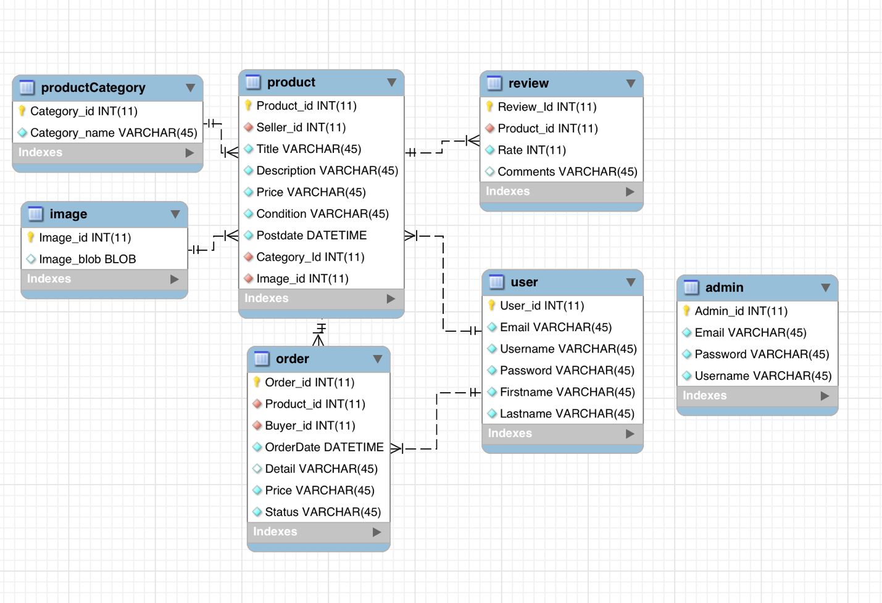

**User Table:**

|  |
| --- |
| **Users** |
| User_id - int PK |
| Username – varchar |
| Firstname - varchar |
| Lastname - varchar |
| Email - varchar |
| Password - varchar |

**Admin Table:**

|  |
| --- |
| **Admin** |
| Admin_id - int PK |
| Username – varchar |
| Email - varchar |
| Password - varchar |

**Product Table:**

|  |
| --- |
| **Product** |
| Product_id - int PK |
| Seller_id – int FK |
| Category_id – int FK |
| Image_id – int FK |
| Title - varchar |
| Description- varchar |
| Price- decimal |
| Condition -varchar |
| Postdate - datetime |

FK: Seller_id refer to user table;

Image_id refer to image table;

Category_id refer to productCategory table;

**ProductCategory Table:**

|  |
| --- |
| **ProductCategory** |
| Category_id - int PK |
| Category_name - varchar |

**Order Table:**

|  |
| --- |
| **Order** |
| Order_id - int PK |
| Product_id – int FK |
| Buyer_id – int FK |
| OrderDate - datetime |
| Detail- varchar |
| Price- decimal |
| Status - varchar |

FK: Buyer_id refer to user table;

Product_id refer to product table;

**Review Table:**

|  |
| --- |
| **Review** |
| Review_id - int PK |
| Product_id – int FK |
| Rate – int |
| Comments - varchar |

FK: Product_id refer to product table;

### **Images:**

|  |
| --- |
| **Image** |
| Image_id – int PK |
| Product_id – int FK |
| Image_blob - blob |

FK: Product_id refer to product table;

**Confirm Table:**

|  |
| --- |
| **Confirm** |
| Comfirm_id - int PK |
| User_id – int FK |
| Key– varchar |
| Email – varchar |

FK: User_id refer to user table;

**Image:**

All images shall be stored and retrieved in the image table as BLOB’s. It's easier to keep all database entries valid with foreign keys, and easier for maintenance.

**Search Algorithm:**

Search algorithm will be enabled via SQL query based on entries in the product table.

We provide search by keyword:

SELECT * FROM `product` WHERE description LIKE '%{$keyword}%';

And search by category:

SELECT * FROM `product` WHERE category_id = $category_id AND description LIKE '%{$keyword}%';

1. High Level UML Diagrams

* High-level UML class diagram

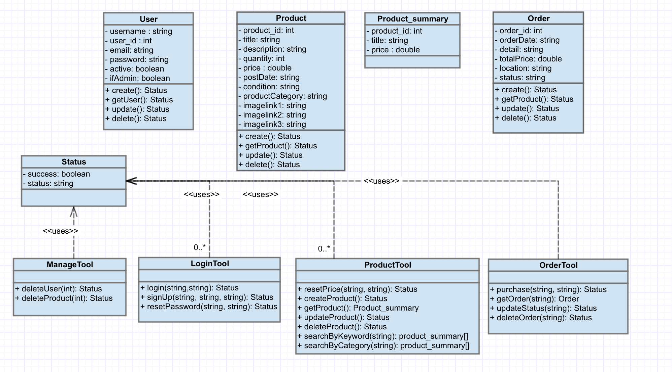

* UML component and deployment diagram

sfsuswe Web Server

Gatorslist WebApp

Web Application

<<Database>>

su16g01 MySQL server

TCP/IP

User PC

Web Browser

1. High level APIs

**Status:**

- Boolean: success

- String: status

**Login Tool:**

* Function *login* takes the information from both the email and password forms that the user fills in. If the email is in the database and the supplied password is correctly corresponding to that email in the database, it will return a status of whether the login was successful.

+ login(email STRING, password STRING)

Return: Status

* Function signUp takes the string username, email and checkpassword. Usually user fills their password two times. The two passwords are checked whether they are equal and if they are, the username, email and password is newly passed into the database as a new user account with the appropriate data fields inserted. It will return a status depending whether account creation has been successful.

+ signUp(username STRING, email STRING, checkpassword STRING)

Return: Status

* Function *resetUserPassword* takes the username, old password and new password from the user and if the old password is correctly linked to the username in the database, the new password will replace it in the data field. It will return a status depending on if the password has been updated.

+ resetUserPassword(username STRING, oldpwd STRING, newpwd STRING)

Return: Status

**Product Tool:**

* Function *getProduct* obtains the product id and uses it to search the database and display all of the other corresponding data fields from the same table. These data fields are used to populate the product page with all of the related information.

+ getProduct(product_id INT)

Return: Null - if the product ID is not in the database

Associated array includes

String: Seller’s name

String: Title

Double: Price

String: Condition

Datetime: Postdate

Image

* Function *getResultsByKeyword* takes in the keyboard the user has input into the search bar and searches through the database for any listings that include that keyword. If it has found any listings, it will return all related product id’s and if there are no available listings, null.

+ getResultsByKeyword(keyword STRING)

Return: Null – if no products contains keyword

Associated array includes

String: Seller’s name

String: Title

Double: Price

String: Condition

Datetime: Postdate

Image

* Function *getResultsByCategory* takes a category id as an argument. Using this category id, it will search through the database and if there are any listings with that value of category id, it will return them. Otherwise, it will return null if there are no items with that category id available.

+ getResultsByCategory(Category_id INT, keyword STRING)

Return: Null – if no category ID in the database

Associated array includes

String: Seller’s name

String: Title

Double: Price

String: Condition

Datetime: Postdate

Image

* Function *resetPrice* will take the product id and the new price that the buyer wants to set their product for. It finds the row containing that product id and replaces the old value of the price data field with the new desired price.

+ resetPrice(product_id INT, newprice DOUBLE)

Return: Status

* Function *deleteProduct* accepts the product id as an argument and it will use it to delete the corresponding row from the database table containing products.

+ deleteProduct(product_id INT)

Return: Status

**Order Tool:**

* Function *getOrder* accepts an order id as an argument and using it, the function searches the database for any orders with that particular order id and if it is found, it will return the rest of the row from the database table like the price and the order date.

+ getOrder(order_id INT)

Return:Null – if order ID is not in the database

Associated array includes

String: Product name

String: Buyer’s name

Double: Total

Datetime: OrderDate

String: Status

String: Location

String: Detail

* Function *purchase* takes both product id and the buyer’s user id as parameters; it will return whether the purchase has been successful depending whether the buyer has sent the payment and the payment has properly been receiver by the seller.

+purchase(product_id INT, user_id INT)

Return: Status

**Manage Tool:**

* Function *deleteUser* will take the user id of the user’s account that is selected to be deleted. The entire row corresponding to that user id will then be deleted from the database and return whether it has been successfully deleted.

+deleteUser(user_id INT)

Return: Status

* Function *deleteProduct* accepts the product id as an argument and it will use it to delete the corresponding row from the database table containing products.

+deleteProduct(product_id INT)

Return: Status

1. Key Risks

**Skill Risks**

* The group is inexperienced with the technologies used for this project
* Resolution: Everyone will have to dive right in and learn the basics of the technologies regardless of role.

**Schedule Risks**

* There are some scheduling conflicts where we are unable to spend time in person as a group for more than an hour. All members are taking additional classes, the group, tech, and another member have part time jobs.
* Resolution: We will have to schedule skype meetings to make up for the lack of face time.

**Technical Risks**

* There are risks with the use of git most of us have not used git hands on yet. We have never used MySQL workbench or worked with a database before.
* Resolution: We will be teaching each other about git and MySQL as we progress.

**Teamwork Risks**

* Tasks may be not completed in a timely manner.
* Resolution: We have set up a task sheet to keep track of what everyone’s doing and to make sure that we’re on track and not doing unnecessary tasks.

**Legal/content Risk**

* There may be risks of unauthorized usage of content/SW.
* Resolution: We will be reading the terms of service carefully as we use them.

1. Team Organization

|  |  |
| --- | --- |
| **Name** | **Role** |
| Khalid Alrashed | Team Lead: Will be looking over the back-end for any issues and also finalizes and formats all documentation, on top of overall project management. |
| Eric Chen | Tech Lead/Frontend: Will be mainly working on the front-end, the workflow of the group, quality assurance, and user experience. |
| Robert Chung | Backend: Developer for the back-end features of Gatorslist. |
| Tai Nguyen | Frontend: Will be working on the front-end with analyzing the logic of website flows based on documentation. |
| Guoyi Ruan | Backend: In charge of Database and back-end development. |